ROYAL OAK INTERNATIONAL SCHOOL
SR. SEC. CBSE AFFILIATED
HOLIDAY HOME WORK (SESSION 2019-20)
Class - V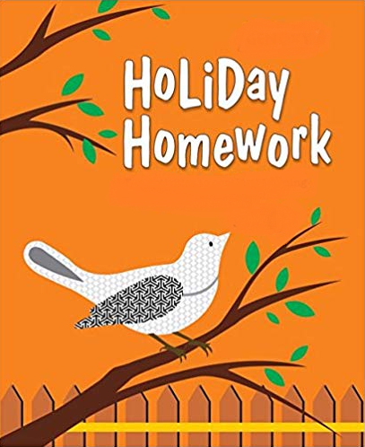

Please note the following:
- HHW of 5 marks will be added as a subject enrichment activity marks in Term I, hence submission of work post summer vacation is compulsory for all the students.
- Schedule for the Submission of HHW for all classes is as follows:
English : 3/07/2019
Hindi : 4/07/2019
Math : 5/07/2019
Science : 8/07/2019
Social Studies : 9/07/2019
- Submission dates for Computer, G.K., Art & Craft will be in the 2nd week of July.

Wishing you all a very fruitful and enjoyable vacations. HAPPY HOLIDAY!

FOR THE PARENTS

Summer Vacations are here. A few vital suggestions are listed below to make the vacations more exciting and fruitful than ever before:
- Keep at least half an hour a day for sharing experiences with your child.
- Encourage your child to speak in English. Fix one hour in a day when you communicate with your child only in English.
- Tell your child different stories regularly and encourage him/her to describe what he/she would do in a similar situation. Here are few suggested titles which you can read with your child.
a. Lacey-the little mermaid fairy d. Giraffe can’t dance
b. I like myself (Story book) e. Dolphins at the day break
c. Panchatantra stories
- Let your child colour, draw, paint, Play, Dance etc.
- Restrict his/her television watching, confining it to interesting children’s program, cartoon films, discovery channel etc.
- To improve the formation of letter, make your child write a page every day.
- Develop self help skills: Let your child dress and feed on his/her own.
- Make him/her understand the importance of cleaning his/her room and putting away toys and belongings after use.
- Take your child out for picnics and to other places of his/her interest. Ask him/her to make a note of all the places he/she visits and things he/she sees so that he/she is able to discuss his/her experience in class after vacations.
Have a nice time!
PRINCIPAL

ENGLISH:
1.Tongue twisters are great fun. Try learning these tongue twisters and practicing saying these quickly as possible. We will be organizing an intra class tongue twister competition in the class after the summer vacation. So. Learn these tongue twisters and come prepared.
- She sells sea shells by the seashore.
- Eve eating eagerly Easter eggs.
- I like New York, unique New York, I like unique New York.
2. Read the newspaper regularly during your holidays. You may utilize the noon time for this activity when you are at home. Cut five pictures from old newspaper. Paste them in your language notebook and give a caption to each picture.
3. Make a chart on different types of sentences and its kinds with examples and pictures.
4. Converse in English with your family members and listen to English news daily.
5. “WORDS I MUST KNOW” Make a vocabulary scrapbook with 50 new words and learn them with their meanings.
HINDI:
- ikB u0 & 1 ls 3 ;kn djks A
- fdlh Hkh ek=k dks cnyus ls mldk vFkZ Hkh cny tkrk gS] tSls lqr & lwr ,sls vkSj 15 tksM+s cukdj A- 4 “khV ij fy[ksA
- ^ LoPNrk vfHk;ku * ij fp= lfgr ik¡p Lyksxu A- 3 “khV ij fy[ksaA
- ^ jDrnku egknku * fo’k; ij ik¡p lqfopkj A- 4 “khV ij fy[kasA
- vkius xzh’eodk”k dgk¡ fcrk;k fp= lfgr ¼70& 80 “kCnksa esa½ A- 3 Size Sheet ij vuqPNsn fy[ksa A

MATH:
- Prepare a small notebook and do the following work in it.
- Ch- 1 (Revision)
- Ch-2 (Roman Numerals)
- 27 is a multiple of 3.If you reverse 27 and is 72, it is also a multiple of 3.Such multiples are called magic multiples.
Find all the magic multiples of 5 &9 from 1-100.
- Collect 5 Indian coins of different years. Paste them on A-3 size sheet and write their respective years in Roman numerals with match sticks.
- Revise all the work done in a class for P.A-I
- Learn and write tables from 2-25.

SCIENCE:
1. Draw and colour a poster on Save Environment. Also write a catchy slogan on it.Do it on A-3 Sheet.
2. Make an attractive model using cardboard or thermocol on different types of pollution according to your Roll No
- Roll No-1 to 9- Air pollution
- Roll No- 10 to 18-Water pollution
- Roll No- 19 to 27-Noise pollution
- Roll No- 28 to 35- Land pollution
3. Learn L-1, 2, 3 and 6
SOCIAL STUDIES:
1.Collect the stamps of India and other countries of the world and make a beautiful collage on an A4 Sheet.
2.Make a model of an iceberg with the help of thermocol.
3.Make a thermometer and a stethoscope with waste material.
4. Revise all the chapters done in class for PA-I.

COMPUTER:
- Revise P.A.-I Syllabus
- Do page no.15
- Draw Pictures related to topic mentioned below on A3 sheet.
- Roll No.1 – 10 Anatomy of computer(Refer Pg- 7)
- Roll No. 11 – 20 Scratch blocks of scratch and their usage (Refer Pg-113)
- Roll No. 21-25 Shortcut Keyboard commands (Refer Pg-42)
- Roll No. 25 onwards Collage of Input and Output devices
4. Make a Power Point presentation on the following (minimum 5 slides)
- Roll No 1 – 18 : “Generations of Computer”
- Roll No 19-40 : “Memory and Storage Devices”
Note: Take a printout and paste it in the scrap file.

G.K.:
1. (a) Gadgets have changed the way we live. They have made our lives more comfortable and less boring.Paste the pictures of any six Hi – tech gadgets and label them.
(On A3 size sheet) (Roll No. 1 to 15)
(b) Paste the pictures of any seven Medicinal Plants and write why they are useful to us.
(On A3 size sheet) ( Roll No. 16 onwards)
2. Revise P. A. I Syllabus.

ART & CRAFT:
1. Jewellery with quilling work (ear ring, necklace)
2. Pen holder (Ref. page no 39 in Art & Craft book)

